**Assignment No: 1**

**Date: 22/2/2022**

**Title:**

(Title based on the application domain and the data structure you will be implementing)

|  |  |  |  |
| --- | --- | --- | --- |
| **Assignment Type of Submission:** |  |  |  |
| **Group** | Yes | **List all group members’ details:**  Student Name: Abhishek Suresh  Student ID: 21200458  Student Name  Student ID | **% Contribution**  **Assignment Workload**  ?  ? |

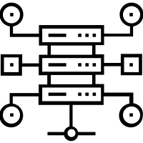

1. **Problem Domain Description:**
2. **Theoretical Foundations of the Data Structure(s) utilised**
3. **Analysis/Design (UML Diagram(s))**

1. **Code Implementation**

GitHub (link):

Set of Experiments run and results

Comments:

1. **Video of the Implementation running**

Zoom (link & password):

Comments:

**Please save as pdf and submit on Brightspace**

**Students belonging to the same group can submit the same file .**